Dynamics of Discrimination

World History, 10th Grade

Day 12/13 of 17 day unit

CA Content Standards
10.7.3 - Analyze the rise, aggression, and human costs of totalitarian regimes (Fascist and Communist) in Germany, Italy, and the Soviet Union, noting especially their common and dissimilar traits.

CCSS (Grade 9-10)
CCSS.ELA-Literacy.RH.9-10.9
Compare and contrast treatments of the same topic in several primary and secondary sources.

CA ELD Standards (Grade 9-10)
Collaborative, 2. Interacting via written English (Bridging)
Collaborate with peers to engage in a variety of extended written exchanges and complex grade‐appropriate writing projects, using technology as appropriate.

Big Idea/Enduring Understanding: We are all a part of the human race. There are benefits and drawbacks to identifying people by their ethnic or racial qualities.

Objective/Learning Goal: Students will be able to analyze why different people might perceive the same events in different ways

Differentiation: I will model the assignment and provide my example, offer some students the advice of preparing index cards to guide their short presentation and the option of different media and hands-on work to entice different learning styles

Assessment: Summative assessment, reflections graded according to rubric with category for presentation

Instructional Strategies: Teacher will review the practice of using ethnic, racial and behavioral characteristics to classify people into supposedly distinct groups. Teacher will introduce the project where each student develops something that they can share with the class in about 2 minutes that reflects how they identify themselves. Teacher will then facilitate presentations and ask that the students make a note of something they share in common with each presenter. Teacher will lead the discussion at the conclusion of the activity.

Student Activities: Students will prepare presentations, give a two minute presentation and record one aspect of each presentation that they can relate to. At the end of the activity students will break into groups according to the presentation similarities they noted and their insights on how to classify people into different groups. After this activity is completed students will defend or question their selection and discuss the realities of identifying with or neglecting to identify with individuals based on their genetic or behavioral characteristics. After the de-briefing students will write a short reflection on the nature of discrimination taking into account the events of WWII and what they saw as a class.

Resources:
My modeled presentation
Presentation rubric (see below)
T4 Medical Questionnaire 1
Used for questioning institutionalized patients in Germany, 1933:
(see below)
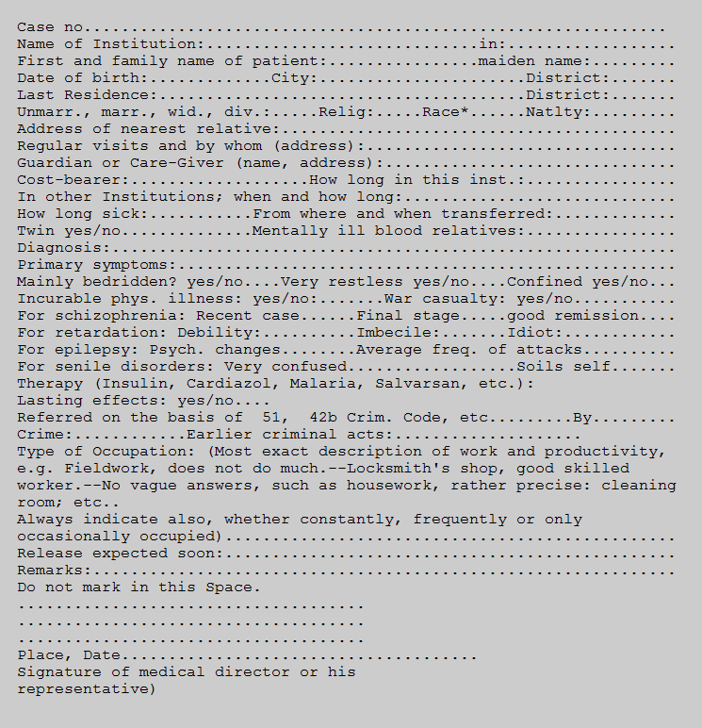
*German or related blood (German-blooded), Jew, Jewish Mischling (half-breed) 1st or 2nd degree, Negro (Mischling), Gypsy (Mischling), etc. Translated in Robert J. Lifton, The Nazi Doctors: Medical Killing and the Psychology of Genocide (New York, 1986), pp. 68-69.

Dynamics of Discrimination Rubric
 | 4 | 3 | 2 | 1
Content | Reflection conveys extensive evidence of a personal response to the issues raised in the course materials. Student demonstrates personal growth and awareness  Reflects well on own work, demonstrates a range of meta-cognitive practices and provides many examples | Reflection conveys evidence of a personal response to the issues raised in the course materials. Student demonstrates that he/she is beginning to develop new ways of reflecting on their world. Demonstrates an ability to reflect on own work. Provides examples consistently. Begins to demonstrate good meta-cognition. | Analysis conveys little or some evidence of a personal response to the issues/concepts raised in the course materials. Demonstrates an ability to reflect on own work but provides few examples | No personal response is made to the issues/concepts raised in the course materials. Does not reflect on own work at all and no examples are provided
Evidence and details | Is able to make inferences well and comprehends deeper meaning, consistently demonstrating insight and their relevance to the world and society | Is able to make inferences and comprehends deeper meaning on most occasions. Relates texts and issues raised to other texts consistently | Demonstrates some basic comprehension of texts but does not make connections with the bigger picture. | Is not comprehending or reflecting on what is read or viewed
Tasks | Work demonstrates that much effort was made to attempt all tasks set, with some originality and extra initiative | Work demonstrates that some effort was made to attempt all tasks set | Little effort was made to attempt all tasks set | Very little effort was made to attempt all tasks set
Use of language | Student brilliantly uses language and historical terms to develop an argument | Student selects appropriate language and terms to develop an argument | Student’s language choices detract from the argument | Student’s language choices are extremely problematic to the development of an argument
Mechanics | Student’s grammar, structure and organization are excellent. Errors are nonexistent | Student’s grammar, structure and organization are satisfactory. If errors exist they are insignificant. | Student’s grammar, structure and organization are substandard. Errors are present and detract from the writing | Student’s grammar, structure and organization are extremely deficient.

